 | Ahmed Abouel-Kasem Ahmed Mohamed
 | Professor of Machine Design  Mechanical Engineering Department,  Faculty of Engineering-Rabigh,  King Abdulaziz University,  P.O. Box 344,  Rabigh 21911, Saudi Arabia;  Department of Mechanical Engineering,  Assiut University,  Assiut 71516, Egypt  Email: Abouelkasem@yahoo.com  096656529823 (Saudi, Mobile)  Date of Birth: Jule 29, 1969.  Place of Birth: Alexandria, Egypt.  Home Address: Alexandria, Miami, Borg Almohagreen, 16 ^{th} floor, 62th flat. |  | 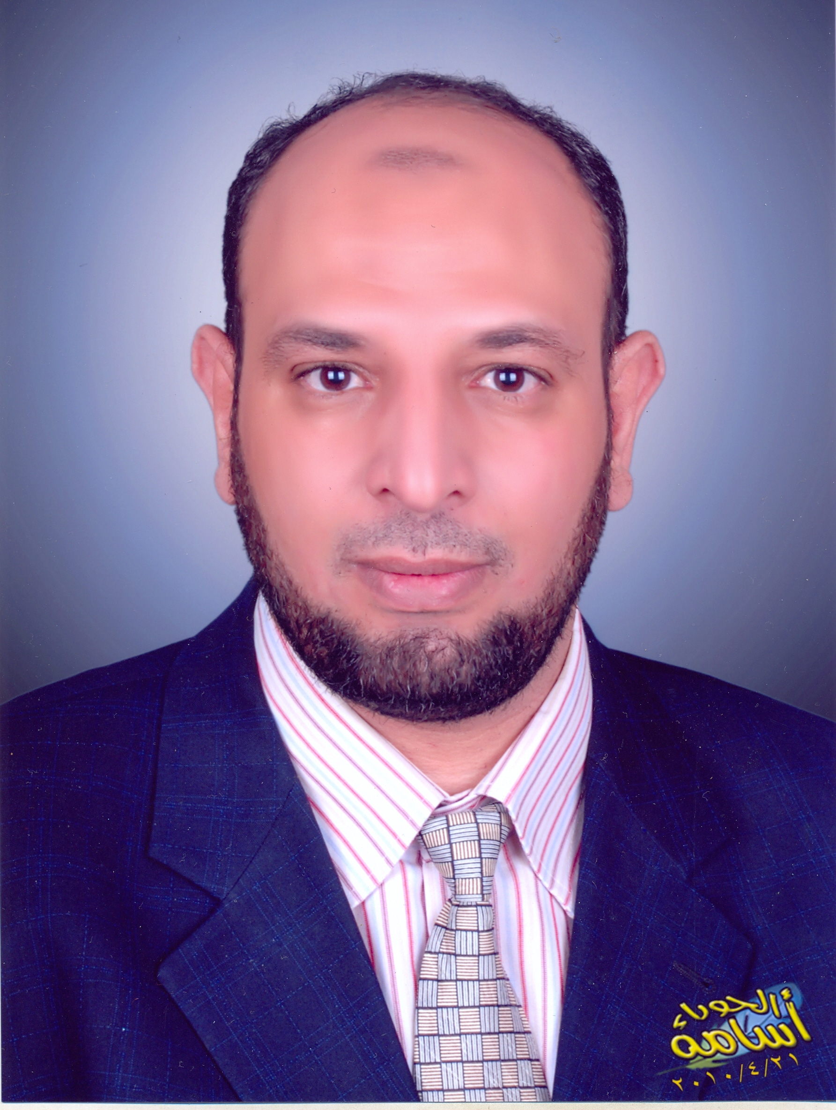
Nationality |  | Current: Egyptian Previous: None
Education: |  | University of San Peter Porg, Russia, May 2002. (05.02.02)  Doctor of Philosophy, Dissertation Title, “Method of Calculating the Serviceability Elastomeric Parts Taken into Consideration the Elasto-Visco-Plastic Properties of the Material’’  Assiut University, Assiut, Egypt, July 1997.  Master of Science in Mechanical Engineering, Thesis Title, “Study of Stressess and Strains in Viscoelastic Gear Tooth”  Assiut University, Assiut, Egypt, July 1992.  Bachelor of Science in Mechanical Engineering  - Ranked First in Class Magna Cum Laude.
Major Research: |  | - Fractal Characterization of eroded surface  - Cavitation erosion and slurry erosion of hardened materials (such as boronizing, carburizing)  - Viscoelastic materials behavior by experimental and FEM  - Design of machine parts
Work Experience: |  | Mechanical Engineering Department, King Abdulaziz university, Saudi Arabia. Professor, October, 2013 – present.  - Teaching the following courses: Machine Design, Machine Drawing and constructions, workshop, Engineering Drawing.  - Searching in Tribology. (3 articles published in International journal).  - Ph. D. &M. Sc. research Co-supervision  Mechanical Engineering Department, King Abdulaziz university, Saudi Arabia. Associate Professor, September, 2010 – October, 2013.  - Teaching the following courses: Machine Design, Machine Drawing and constructions, workshop, Engineering Drawing.  - Searching in Tribology. (17 articles published in International journal).  - Ph. D. &M. Sc. research Co-supervision  Mechanical Engineering Department, Assiut University, Assiut, Egypt. Associate Professor, February, 2008- September, 2010.  - Teaching the following courses: Machine Design, Machine Drawing and constructions, Laboratories, Engineering Drawing, Projects and Theory of Machine.  - Searching in Tribology and Viscoelastic materials. (10 articles published in International journal).  - Ph. D. &M. Sc. research Co-supervision  Mechanical Engineering Department, Assiut University, Assiut, Egypt.  Assistant professor, February, 2003 – February, 2008.  - Teaching the following courses: Machine Design, Machine Drawing and constructions, Workshop technology, Stress Analysis, Manufacturing technology, Laboratories, Engineering Drawing and Failure diagnose.  - Searching in Tribology and Viscoelastic materials. (11 articles published in conferences & international journal).  - M. Sc. research Co-supervision  Mechanical Engineering Department, University of San Peter Porg, Russia, Graduate Research Assistant, 1998 – 2002.  - Research Assistant on numerical simulation of Elasto-Visco-Plastic material behavior  - Searching in Elasto-Visco-Plastic materials. (4 articles published in conferences).  - Co-Supervising senior design projects.  Mechanical Engineering Department, Assiut University, Assiut, Egypt.  Assistant Lecturer, 1992 – 1998.  Taught and assisted in teaching the following undergraduate courses:  Machine Design, Machine Drawing and constructions, Workshop technology, Stress Analysis, Theory of machine, Vibration, Engineering of mechanics, Engineering Drawing, and Mechanical Engineering Laboratories.  - Searching in Viscoelastic materials. (4 articles published in conferences).  Co-Supervised senior design projects.
Publications: |  | - International Journals  B- Egyptian Journals  C- International Conferences  Published Books  (1) Karam M. M. Emara, Farouk M. F. Badran and Ahmed Abouel-Kasem "Machine Drawing and Construction I" Assiut University (2004).  (2) Karam M. M. Emara, and Ahmed Abouel-Kasem "Machine Drawing and Construction II" Assiut University (2009).  (3) Karam M. M. Emara, and Ahmed Abouel-Kasem "Machine Design I" Assiut University (2004).  (4) Karam M. M. Emara , and Ahmed Abouel-Kasem :"Machine Design Problems and projects" Assiut University (2008).  (5) Karam M. M. Emara, Shemy M A. and Ahmed Abouel-Kasem "Principles of Engineering Drawing” Assiut University press (IN ARABIC) (2008).
  - A. Abouel-Kasem, I. M. Hassab -Allah, and M. M. Nemat-Alla, “Analysis and Design of Viscoelastic Adhesively Bonded Tubular Joint” JEAS, Journal of Engineering and Applied Sciences, 2014, Vol. 1 / 13-23
  - Y. M. Abd-Elrhman, A. Abouel-Kasem, K.M. Emara, and S. M. Ahmed “Stepwise erosion as a method for investigating the wear mechanisms at different impact angles in slurry erosion", ASME, J. Tribol, April, 2014, Vol. 136 / 021608-1
  - Y.M Abdel-Rahman, A. Abouel-Kasem, K.M. Emara, S.M. Ahmed " Effect of Impact Angle on Slurry Erosion Behavior and Mechanisms of Carburized AISI 5117 Steel", ASME, J. Tribol, January 2014, Vol. 136 / 011106-1
  - F. A. Alturki, A., Abouel-Kasem and S.M., Ahmed "Characteristics of cavitation erosion using image processing techniques" ASME, J. Tribol. January, 2013, Vol. 135, 014502-1
  - Mahmoud A. El-Sharief, Hassan, M.A, Abouel-Kasem, A., Ramesh, S. and J. Purbolaksono "A Fuzzy Model for Evaluation, Prediction and Control of Slurry Erosion of Ductile Materials" Elsevier Ltd., materials & design, August 2012 Vol 39, pp 186-191.
  - Hassan, M.A, Abouel-Kasem, A., Mahmoud A. El-Sharief, and Yusof, F., "Evaluayion of the Material Constants of Nitrile Butadine Rubbers (NBR) with Different Carbon Black (CB): FE Simulation and Experimental" Elsevier Ltd., Polymer , June 2012, Vol 53, pp. 3807-3814
  - A. Abouel-Kasem, and S.M. Ahmed " Bubble Structures between Two walls in Ultrasonic Cavitation Erosion " ASME, J. Tribol. April, 2012, Vol. 134 / 021702-1
  - A. Abouel-Kasem, F. A. Alturki, and S.M. Ahmed "Fractal Analysis of Cavitation Eroded Surface in Dilute Emulsions" ASME, J. Tribol. October, 2011, Vol. 133 / 041403-1
  - Abed elwahab and A. Abouel-Kasem, "Tribological Characteristics of Deformed Magnesium Alloy AZ61 Under Dry Condition " ASME, J. Tribol. October, 2011, Vol. 133 / 041602-1
  - A. Abouel-Kasem, "Particle Size Effects on Slurry Erosion of 5117 steels" ASME, J. Tribol. January, 2011, Vol. 133 / 014502-1
  - 8- Saleh, B., A. Abouel-Kasem, A. Ezz El-Deen, S.M. Ahmed "Investigation of Temperature Effects on Cavitation Erosion Behavior Based on Analysis of Erosion Particles" ASME, J. Tribol, OCTOBER 2010, Vol. 132 / 041601-6
  - A. Abouel-Kasem, Y.M Abdel-Rahman , K.M. Emara, S.M. Ahmed "Design and performance of slurry Erosion tester", ASME, J. Tribol, APRIL 2010, Vol. 132 / 031601-10
  - A. Mostafa, A. Abouel-Kasem, M.R. Bayoumi, M.G. El-Sebaie “Rubber-Filler Interactions and Its Effect in Rheological and Mechanical Properties of Filler Compounds" Journal of Testing and Evaluation (JTE), Vol. 38 (3) 2010
  - A. Abouel-Kasem, M.A. Al-Bukhaiti, K.M. Emara, S.M. Ahmed "Fractal Characterization of Slurry Eroded Surfaces at Different Impact Angles" ASME, J. Tribol. JULY 2009, Vol. 131 / 031601-9
  - A. Abouel-Kasem, A. Ezz El-Deen,K.M. Emara, S.M. Ahmed "Investigation Into Cavitation Erosion Pits" ASME, J. Tribol. JULY 2009, Vol. 131 / 031605-1-7
  - A. Mostafa, A. Abouel-Kasem, M.R. Bayoumi, M.G. El-Sebaie "On the influence of CB loading on the creep and relaxation behavior of SBR and NBR rubber vulcanizates" J Materials & Design, Volume 30, 2009, Pages 2721–2725
  - A. Mostafa, A. Abouel-Kasem, M.R. Bayoumi, M.G. El-Sebaie "The influence of CB loading on thermal aging resistance of SBR and NBR rubber compounds under different aging temperature" J Materials & Design, Volume 30, Issue 3, March 2009, Pages 791-795
  - A. Abouel-Kasem, K.M. Emara, S.M. Ahmed "Characterizing cavitation erosion particles by analysis of SEM images" J Tribology International, Volume 42, Issue 1, January 2009, Pages 130-136
  - A. Mostafa, A. Abouel-Kasem, M.R. Bayoumi, M.G. El-Sebaie "Insight into the effect of CB loading on tension, compression, hardness and abrasion properties of SBR and NBR filled compounds" Materials & Design, Volume 30, Issue 5, May 2009, Pages 1785-1791
  - A. Mostafa, A. Abouel-Kasem, M.R. Bayoumi, M.G. El-Sebaie "Effect of carbon black loading on the swelling and compression set behavior of SBR and NBR rubber compounds" Materials & Design, Volume 30, Issue 5, May 2009, Pages 1561-1568
  - Abouel-Kasem, A., Saleh, B., and Ahmed, S. A., "Quantitative Analysis of Cavitation Erosion Particle Morphology in Dilute Emulsions", ASME, J. Tribol. 130, OCTOBER (2008), 0416031-6.
  - Abouel-Kasem, A., and Ahmed, S. A., "Cavitation Erosion Mechanism Based on Analysis of Erosion Particles" ASME, J. Tribol. 130, JULY (2008), 031601-6
  - Abouel-Kasem, A., "Numerical analysis of leakage rate for the selection of elastomeric sealing materials" J. Sealing Technology, Volume 2006, Issue 11, November 2006, Pages 7-11.
  - Abouel-Kasem, A., "Lifetime estimation and design of elastomeric seals with reinforced metal end caps", J. Sealing Technology, Volume 2006, Issue 3, March 2006, Pages 5-9.
  - Abouel-Kasem, A., “Characterizing Cavitation Erosion Particle by Analysis Of SEM Images” Journal of Engineering Sciences, Assiut University, Vol., 34, No., 6, November 2006, p.1865.
  - Abouel-Kasem, A., “Numerical analysis of leakage rate for selection of elastomeric sealing material” Journal of Engineering Sciences, Assiut University, Vol., 33 , No., 6, November 2005
  - Abouel-Kasem, A., Ezz El-Deen, A, Ahmed, S. M., Abdellah, G.A.E., “Effect of horn-tip shape on cavitation erosion of stationary specimen in a vibratory facility” Journal of Engineering Sciences, Assiut University, Vol.33, No.1 (2005), p.185.
  - Abouel-Kasem, A. “Lifetime estimation and new design of the elastomeric rubber seals reinforced with Metal End Caps” Journal of Engineering Sciences, Assiut University, Vol. 32, No. 5, pp. 1977-1991, November 2004
  - Abouel-Kasem, A., Ahmed, S.M., “Cavitation Erosion Mechanism Based on Analysis of Erosion Particles,” EGTRIB J., Vol. 2, No. 3 (2004), p.1.
  - Mahmoud A. El-Sharief, Hassan, M.A and Abouel-Kasem, A., " A Fuzzy Model for Evaluation, Prediction and Control of Slurry Erosion of Ductile Materials" Journal of Engineering Sciences, Assiut University, Vol. 37, No. 6, pp.1449-1461, November 2009.
  - Hassan, M.A, Abouel-Kasem, A. and Mahmoud A. El-Sharief, " Evaluation of the Material Constants of Nitrile Butadine Rubbers (NBR) with Different Carbon Black (CB): FE Simulation and Experimental" Journal of Engineering Sciences, Assiut University, Vol. 38, No. 1, pp. 119-134, January 2010.
  - Y. M. Abd-Elrhman, A. Abouel-Kasem, K.M. Emara, and S. M. Ahmed “Stepwise erosion as a method for investigating the wear mechanisms at different impact angles in slurry erosion” Journal of Eng. Sciences, Assiut University, Vol. 40, No. 4, pp.1055 -1074, July 2012.
  - Y. M. Abd-Elrhman, A. Abouel-Kasem, K.M. Emara, and S. M. Ahmed “Effect of Impact Angle on Slurry Erosion Behaviour and Mechanisms of Carburized AISI 5117 Steel” Journal of Engineering Sciences, Assiut University, Vol. 41 No1 pp.137-157 - January 2013
  - Mostafa,A., Abouel-Kasem, A., Bayoumi, M. R., and El-Sebaie, M. G., “Effect of carbon black loading on the swelling and compression set behavior of SBR and NBR rubber compounds” First Engineering Conference for young researchers ,Faculty of engineering- Assiut University, May 7-8 (2007).
  - Mostafa,A., Abouel-Kasem, A., Bayoumi, M. R., and El-Sebaie, M. G., “Rubber-Filler Interactions and Its Effect in Rheological and Mechanical Properties of Filler Compounds” Fourth Assiut University Int. Conf. on Mech. Eng. Advanced Tech. for Indus. Prod., December 12-14 (2006)
  - Abouel-Kasem, A., Hassab-Allah, I.M and Nemat-Allah, M. “Analysis and Design of Viscoelastic Adhesively Bonded Tubular Joint” Fourth Assiut University Int. Conf. on Mech. Eng. Advanced Tech. for Indus. Prod., December 12-14 (2006)
  - Abouel-Kasem, A.“Lifetime estimation and new design of the elastomeric rubber seals reinforced with Metal End Caps” Journal of Engineering Sciences, Assiut University, Vol. 32, No. 5, pp. 1977-1991, November 2004
  - Hassan, M.A and Abouel-Kasem, A., “A Novel friction aided deep drawing process for production deep square cups”. 8 th Cairo University Int. MDP Conf. Cairo, January 4-6, 2004, pages 961-968.
  - Abouel-Kasem, A., and Hassan, M.A.: “Sliding contact analysis of viscoelastic cylinders”.8 th Cairo University Int. MDP Conf. Cairo, January 4-6, 2004, pages 101-111.
  - Abouel-Kasem, A., Lazarev S.О. “Change of the profile polymeric gear tooth owing to creep”- XXVII Week of a Scienc
  - Abouel-Kasem, A., Lazarev S.О. “Calculation of relaxation and creep for designing sealing of the oil-extracting equipment” - XXVIII Week of a Science SPTU on December 6-11, 2000" Materials of an International scientific conference (Mechanical-machine-building faculty and faculty of technology and research of materials)" SPPGTU, 2001. SPPGTU December 6-11, 1999 "Materials of an International scientific conference (Mechanical-machine-building faculty and faculty of technology and research of materials)" SPPGTU, 2000.
  - Abouel-Kasem, A., Lazarev S.О. “Interaction contact of viscoelastic cylinders with friction: analytical, numerical and experimental results”. Materials V of the All-Russia conference on problems of science and higher school "Basic
  - Abouel-Kasem, A., Lazarev S.О. “Micro elastoviscoplastic model of rubber and its usage for numerical analysis and design of parts”. IV the International conference " Scientific and technical probleresearches at technical universities" SP
  GTU, 200
  .
  - Abouel-Kasem, A., Badran, F. M.F. and Emara, K.M.: “Accumulated Deflection of nylon Gear Tooth Meshing With Steel One”. 5 ts of forecasting of reliability and dura
  ility of
  designs and methods of their solution" SPPGTU, 2001.
  - Abouel-Kasem, A., Badran, F. M.F. and Emara, K.M.: “Stress Strain Analysis in Nylon Gear Tooth in Mesh with Steel One”. 6 th Alexandria University Int. MDP Conf. Alexandria, 15-17 Feb. 1997. Ain Shams University Int. PEDD Conf., 28-30 April, 1998, Cairo
  - Abouel-Kasem, A., Badran, F. M.F. and Emara, K.M.: “Contact Stresses Between Metallic and Voiscoelastic Cylinders”. 6 th Alexandria University Int. MDP Conf. Alexandria, 15-17 Feb. 1997.
  - Abouel-Kasem, A., Badran, F. M.F. and Emara, K.M: “Stress-strain analysis of Viscoelastic Gear tooth”. 6 th Cairo University. Conf. on Design and Production 2-4 Jan. 1996. Cairo.
Teaching Courses:
  - Engineering Drawing | (King Abdulaziz university, Saudi Arabia)  (Assiut University, Egypt)
  - Workshop technology | (King Abdulaziz university, Saudi Arabia)  (Assiut University, Egypt)
  - Stress Analysis | (Assiut University, Egypt)
  - Manufacturing technology | (Assiut University, Egypt)
  - Machine Drawing and constructions | (King Abdulaziz university, Saudi Arabia)  (Assiut University, Egypt)
  - Machine Design I | (King Abdulaziz university, Saudi Arabia) (Assiut University, Egypt)
  - Machine Design II | (King Abdulaziz university, Saudi Arabia)  (Assiut University, Egypt)
  - Theory of Machine | (King Abdulaziz university, Saudi Arabia)  (Arab Academy for Science, Technology & Maritime Transport, Alex., Egypt.)
  - Failure diagnose |  | (Assiut University, Egypt)
Skills & Qualifications: |  | Conferences Steering Committee Membership  Dr. Ahmed Abouel-Kasem was a member for the steering committees of the following conferences:  - MEATIP4, 4rd Assiut University International Conference On Mechanical Engineering Advanced Technology For Industries, December 12-14, (2006), Assiut University, Assiut, Egypt.  - INES2003, IEEE 7th International Conference on Intelligent Engineering Systems, Assiut-Luxor, Egypt, March 4-6, (2003), Assiut University, Assiut, Egypt.  - MEATIP3, 3rd Assiut University International Conference On Mechanical Engineering Advanced Technology For Industries, December 24-26, (2002), Assiut University, Assiut, Egypt.  Design and manufacturing:  - Extensive background in stress analysis (using FEA) and machine design.  - Designed and manufactured of the Machine measurement.  Computer Skills:  - Software Packages: ANSYS, Star for Windows, MathCAD, OUTOCAD and SOLIDWORKS
Awards: |  | Mechanical Engineering Dept., Assiut University, Assiut, Egypt.  - Best student in the Machine Design course award, 1991  - Top Student, 1992
References: |  | - Prof. Dr. Shemy Mohamed Ahmemd Gaber, Mech. Eng. Dept., Faculty of Engineering, Assiut University. (shmey2007@yahoo.com ) - Mobile (0020)185495939  - Prof. Dr. Refat El-sheikh Mohamed El-Zohry, Mech. Eng. Dept., Faculty of Engineering, Assiut University. (refat@aun.edu.eg ) - Mobile (0020)127370723

